Department of Computer Science and Engineering
No. of Pages | 2
No. of Questions | 3
B
MIDTERM EXAMINATION Spring 2011

CSE 110: Programming Language I
CSE 161: Computer Programming
Total Marks: 30 Time Allowed: 1 Hour
- Answer all questions
- Use the answer script for rough work
- Write final answers of Tracing problems on the question paper
- Figure in bracket [] next to each question indicates marks for that question
- At the end of your exam, put the question paper inside the answer script and return both

Name in CAPITAL: _______________________________________________________

ID: __________________________ Course Code: ___________________ Section: ___

Name of Lab Teacher ______________________________ Lab Room Number _____________

Question 1 [10 Points]
Write the pseudo code or draw the flowchart of a program that takes 3 quiz marks from the user, and displays a comment on the student. If average mark is less than 70, say “Bad student”, if it is between 71 and 82, print “Lazy Student”. For all other cases, print “Good Student”.
For example, if the user enters 20, 51, 19, then the average is 30, so you should print “Bad Student”[Answer on the answer-script]

Sl | Sample Input | Sample Output
Example 1 | 16, 41, 70 | Bad Student
Example 2 | 81, 90, 90 | Good Student
Example 3 | 68, 96, 64 | Lazy Student
Example 4 | 22, 86, 80 | Bad Student

Question 2 [10 Points]
Write the pseudo code or draw the flowchart of a program that takes 2 whole numbers from the user, and displays First number raised to the power of the second number. (Use Loop). [Answer on the answer-script]

Sl | Sample Input | Sample Output
Example 1 | 2, 3 | 8
Example 2 | 3, 1 | 3
Example 3 | 5, 2 | 25
Example 4 | 3, 3 | 27

Question 3 [10 Points]

Write the output of the following flowchart: [Answer on the question paper]
Output | 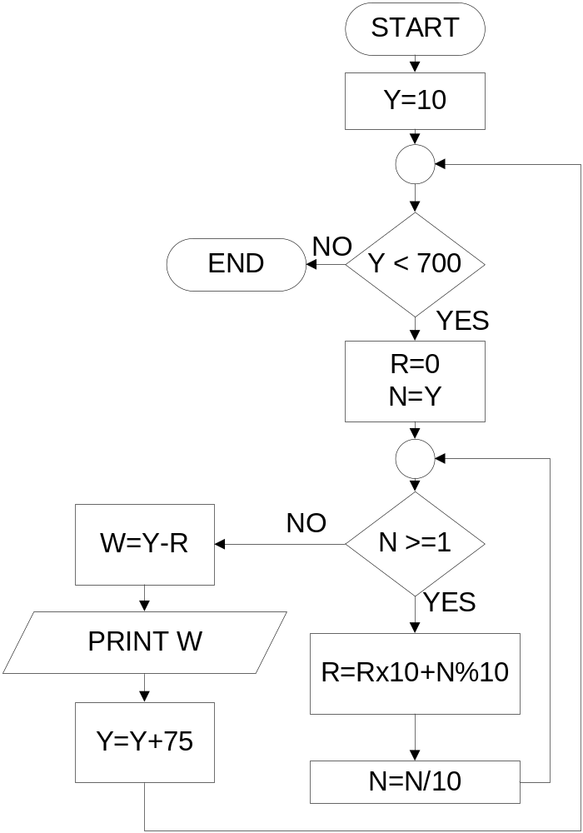Alternate
9 | 9.0
27 | 26.5
99 | 98.4
-297 | -302.35
297 | 296.9
-198 | -203.85000000000002
396 | 395.4
0 | -5.350000000000023
594 | 593.9
99 | 93.14999999999998

